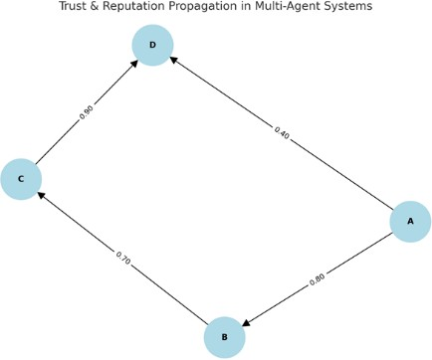
56.Write a Prolog program to simulate trust and reputation in multi-agent systems. Include rules or reputation propagation.
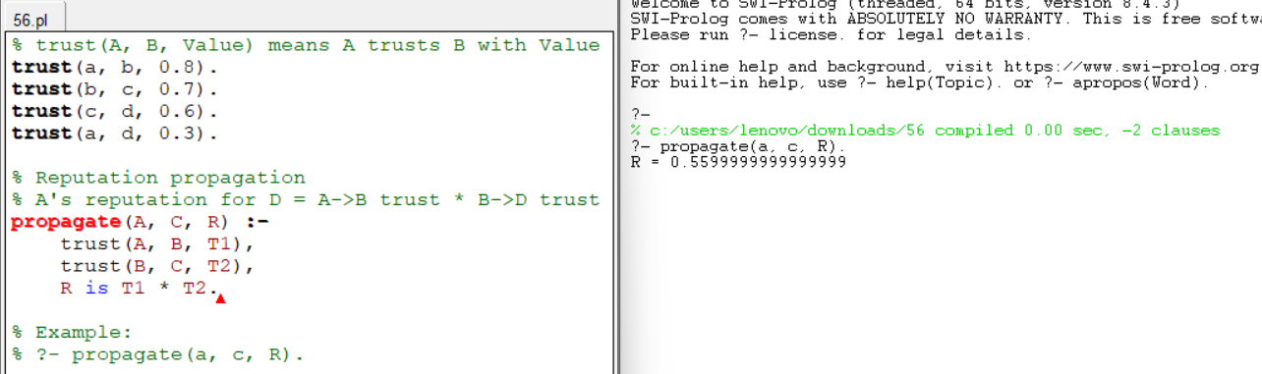
57.Write a Prolog program to demonstrate backward chaining for a simple legal reasoning system (e.g., whether a person is eligible to vote).

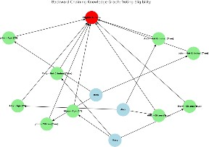

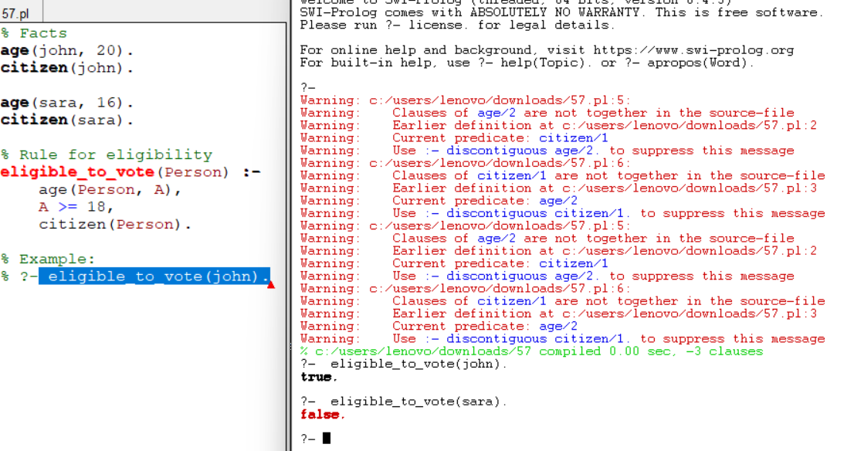

58.Write a Prolog program for semantic network representation of relationships among concepts such as
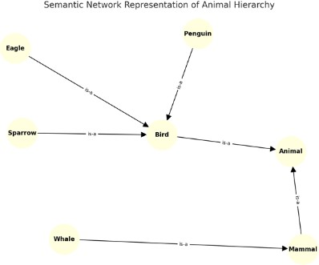
“bird → animal,” “sparrow → bird,” and queries to infer hierarchy.

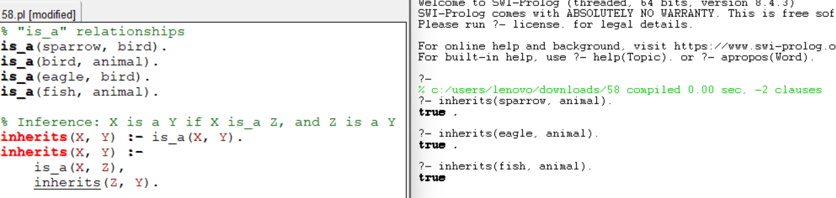

59.Write a Prolog program that models an argumentation framework among agents and checks whether a given argument is accepted or rejected.
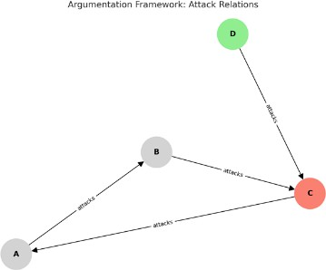

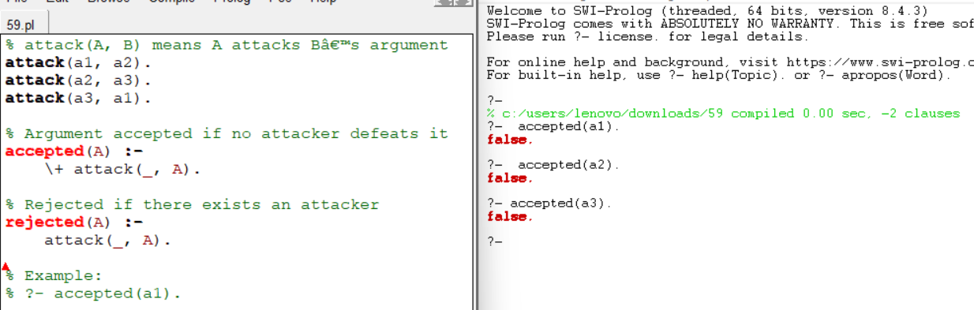
60.Write a Prolog program that represents knowledge using frames. Create frames for “Car,” “Electric Car,” and “Hybrid Car,” and show inheritance of attributes.
